

**Alex**

http://thumbs.gograph.com/gg64297087.jpg

http://thumbs.gograph.com/gg64297087.jpg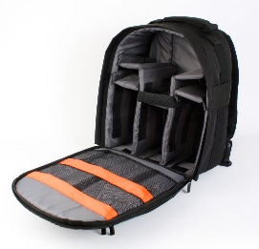



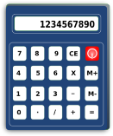http://thumbs.gograph.com/gg64297087.jpghttps://lh6.googleusercontent.com/-fiRj-Uygb7Y/SqOoACnqNtI/AAAAAAAAA9A/BT03yTIG1fo/BXP26585.jpg

http://thumbs.gograph.com/gg64297087.jpg

http://thumbs.gograph.com/gg64297087.jpghttp://thumbs.gograph.com/gg64297087.jpghttps://lh6.googleusercontent.com/-fiRj-Uygb7Y/SqOoACnqNtI/AAAAAAAAA9A/BT03yTIG1fo/BXP26585.jpg

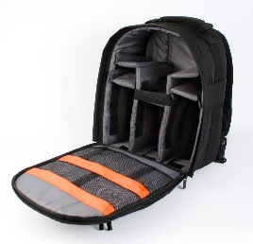http://thumbs.gograph.com/gg64297087.jpg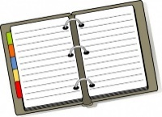http://thumbs.gograph.com/gg64297087.jpghttp://thumbs.gograph.com/gg64297087.jpghttps://lh6.googleusercontent.com/-fiRj-Uygb7Y/SqOoACnqNtI/AAAAAAAAA9A/BT03yTIG1fo/BXP26585.jpghttps://lh6.googleusercontent.com/-fiRj-Uygb7Y/SqOoACnqNtI/AAAAAAAAA9A/BT03yTIG1fo/BXP26585.jpghttps://lh6.googleusercontent.com/-fiRj-Uygb7Y/SqOoACnqNtI/AAAAAAAAA9A/BT03yTIG1fo/BXP26585.jpg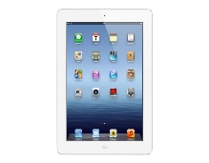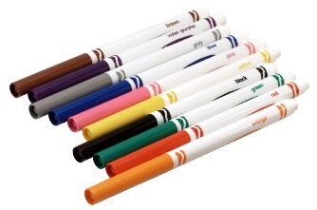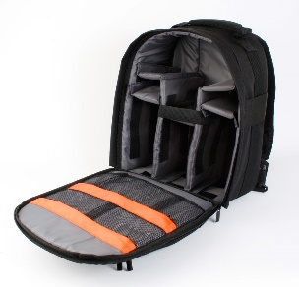

**Elena**

**Juan**

**¿De quién es la mochila?** Work with your partner and say the objects that are out of the backpack. Your partner has to guess who the backpack belongs to. Is it Elena, Juan, or Alex? Take turns asking each other. **Say**: La mochila tiene… (name the objects) When you are done naming the objects, **your partner says**: La mochila es de… (either Alex, Elena or Juan).